Scott West B.Sc. Env, B.Sc. Geo | Senior Project Manager,

347 Leon Ave Suite 210, Kelowna, British Columbia, V1Y 8C7 250-300-7006

[scott.west2@efiglobal.com](mailto:scott.west2@efiglobal.com)

**Professional Summary:**

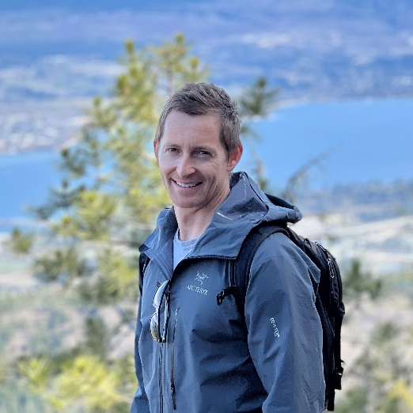Scott west is a Senior Project Manager with EFI Global and has a B.Sc in Environmental Resource Management and a B.Sc in Environmental Geography.

As an environmental technician, Scott acquired extensive expertise in soil, meteorological and water quality instrumentation including custom design, construction and installation of monitoring equipment. Scott has an extensive knowledge of environmental monitoring solutions for a range of clients including Government Agencies, Mining, Agriculture and Heavy Industry and managed various instrumentation and environmental monitoring projects throughout Australia and Singapore.

As an Environmental Advisor for Oil & Gas in QLD, Australia, Scott, developed, managed and monitored the environmental compliance requirements for the project. He managed the environmental team on site, completed technical report writing, required permitting and provided technical oversight to site engineers and construction managers to ensure compliance with regulatory conditions. He was responsible to coordinate onsite environmental factors such as waste management, erosion/sediment control, fauna, vegetation, soil/land reclamation, water quality monitoring, air quality monitoring, weed hygiene and biosecurity. He coordinated the incident response team, managed site remediation and completed the environmental reporting requirements.

Scott served as Senior Environmental Manager for major civil infrastructure construction projects in sensitive habitats, (Great Barrier Reef Marine Park) regulated by municipal, provincial and federal bodies. Scott developed Environmental Management Plans and Erosion and Sediment Control Plans for the project. Scott competed pre and post construction site assessments, environmental field reports, soil assessments and environmental impact assessments for these projects and participated in federal environmental audits during the construction phase.

**Professional Experience:**

|  |  |
| --- | --- |
| Emergency Spill Response / Environmental | Coordinated the environmental incident response team, managed site remediation and completed the environmental reporting requirements for various civil projects in QLD, Australia. |
| Environmental Inspection and Monitoring | * Coordinate all aspects of major highway and foreshore civil reconstruction projects. Produce and manage Construction Environmental Management Plans, Erosion and Sediment Control Plans, Acid Sulphate Soil Management Plans and Vegetation Management Plans. Ensure the environmental protection strategies specified in the plan are implemented during the construction project through planning, communication, installation, monitoring, documentation, reporting and liaison roles. * Participate in government interface procedures including regular field audits and required documentation submission. * Conduct water quality monitoring and automated sampling in both terrestrial and marine environments for a wide range of clients, from municipal, to provincial government, agriculture, mining and industry. * Technical and engineering expertise including design, installation and commissioning of water and air quality monitoring systems, managing project components from inception to completion and providing client support and training. * Conduct data management activities and upgrades such as installation of new monitoring sensors, data display, database management and calibration. * Install, service and maintain sewer monitoring equipment such as MACE and ISCO sensors and equipment. |
| Oil & Gas | * Develop and implement environmental systems, plans and procedures required to fulfill contractual obligations and regulatory compliance requirements of the project. * Manage and monitor environmental compliance practices during the construction phase of the project. * Conduct site assessments and coordinate the environmental monitoring program for site, including conducting environmental sampling and monitoring, instrumentation installation and maintenance, data collection and validation. * Provide technical oversight to site engineers and construction managers to ensure compliance with regulatory conditions and the Environmental Management Plan. * Provide strategic advice to management and field crews to support effective planning of construction, particularly in advance of construction through sensitive areas. * Coordinate critical onsite environmental factors such as waste management, wildlife monitoring and identification, vegetation identification and management, soil/land reclamation, water quality monitoring, weed hygiene and biosecurity. * Coordinate environmental incident response team, including response procedure, personnel, implementation and reporting. * Provide on ground training and advice to construction management and field crews. * Fulfill daily, weekly and monthly environmental reporting requirements and facilitate effective communication between the contractor, the regulator and the principal to increase efficiency during construction planning and staging. * Responsible for budgeting and invoicing environmental contractors and managing budget for special circumstances, i.e. fish transfers, environmental deviations in ROW. |
|  |  |

**Education:**

B.Sc., Environmental Resource Management, Marine Science – Southern Cross University, NSW Australia 2007.

B.Sc., Environmental Geography – University of Hertfordshire, Hatfield, England 2006.

**Specialized Education:**

Ground Disturbance Level I

Standard First Aid with CPR

General Oil & Gas Safety Orientation

WHMIS/TDG/MSDS Certification